NAME: S. DHARANI
REG NO: 192472364
COURSE CODE: DSA0401
NUMPY / PANDAS ANALYSIS – QUESTIONS AND ANSWERS
QUESTION 5: FUEL EFFICIENCY ANALYSIS
AIM:
To calculate average fuel efficiency and percentage improvement between two car models using NumPy.
ALGORITHM:
1. Import NumPy.
2. Create an array of fuel-efficiency values.
3. Find the average using np.mean().
4. Calculate the percentage improvement from Model 1 to Model 2.
5. Display the results.
CODE:
import numpy as np
fuel_efficiency = np.array([25, 30, 35, 40])
average = np.mean(fuel_efficiency)
improvement = (fuel_efficiency[1] - fuel_efficiency[0]) / fuel_efficiency[0] * 100
print("Average fuel efficiency:", average)
print("Improvement:", improvement, "%")
INPUT:
[25, 30, 35, 40] miles per gallon

OUTPUT:
Average fuel efficiency: 32.5
Improvement: 20.0 %
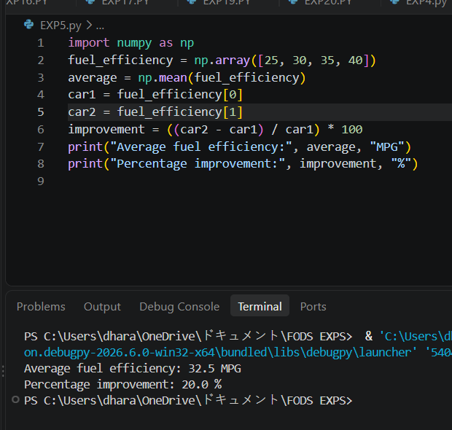
RESULT:
Average fuel efficiency and percentage improvement were calculated successfully.
NOTE: Model 1 = 25 mpg and Model 2 = 30 mpg. Change these values if your dataset is different.

